**Superset ID:6413402**

**WEEK_3-**Spring Core and Maven

**Exercise 1: Configuring a Basic Spring Application**

**Scenario:**

Your company is developing a web application for managing a library. You need to use the Spring Framework to handle the backend operations.

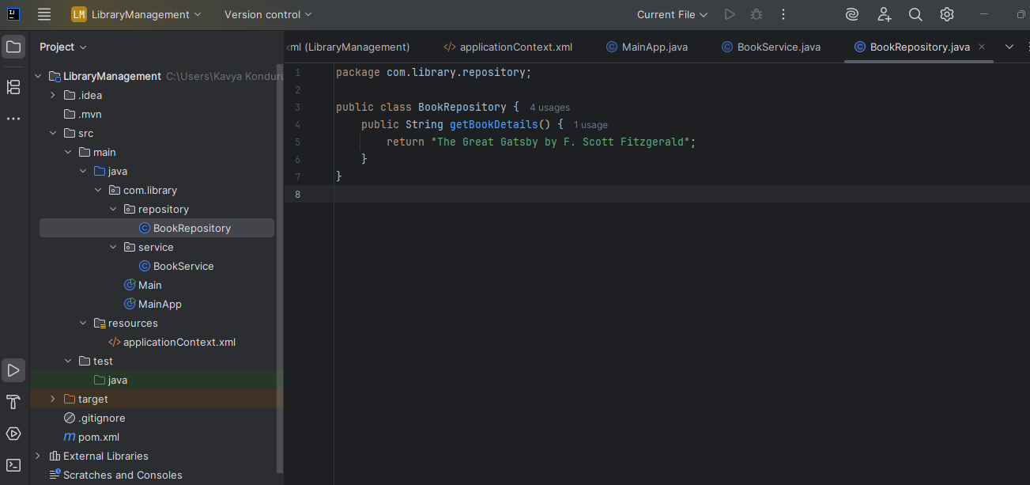

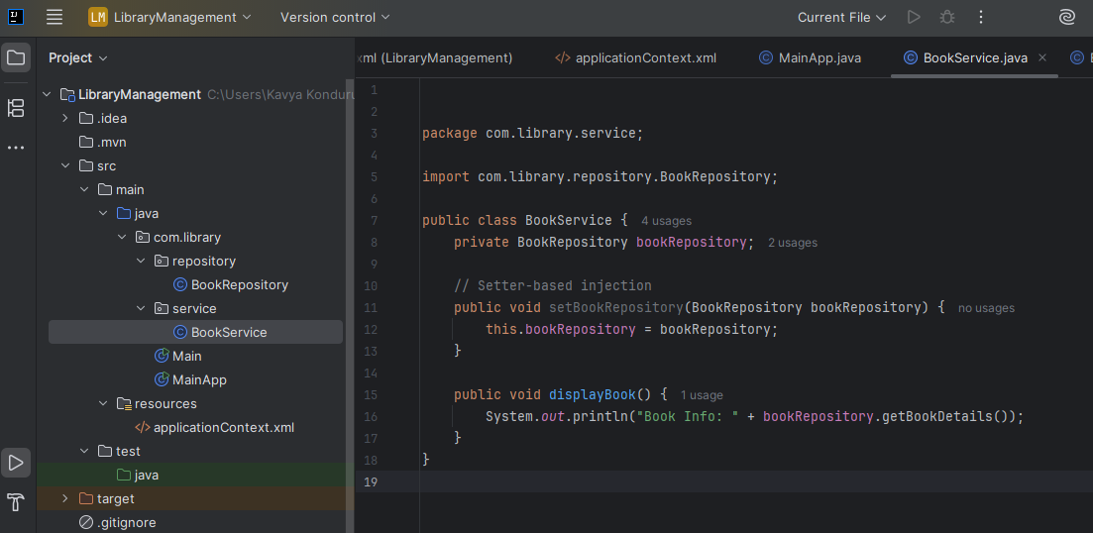

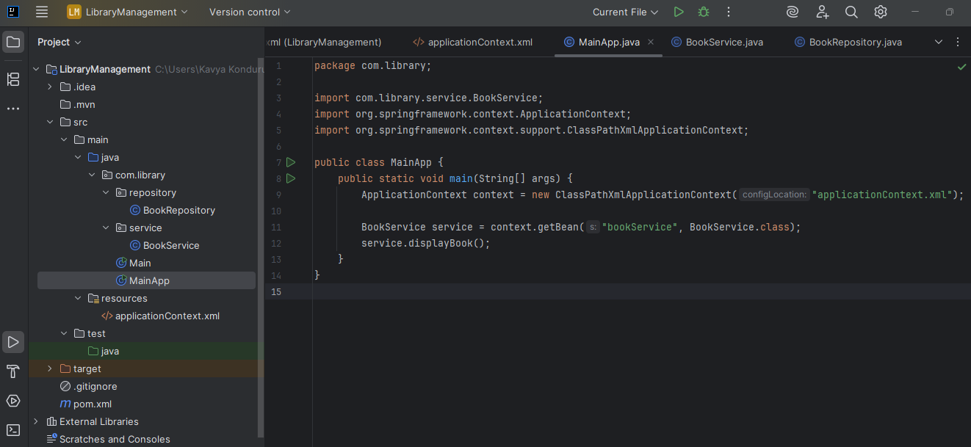

**OUTPUT:**

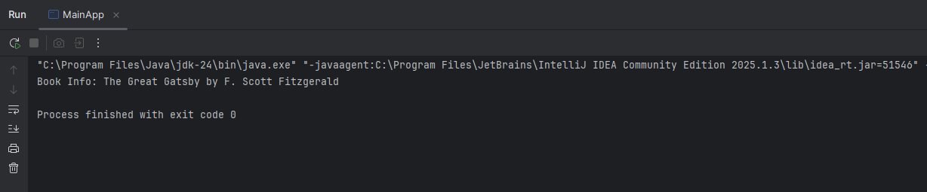

**Exercise 2: Implementing Dependency Injection**

**Scenario:**

In the library management application, you need to manage the dependencies between the BookService and BookRepository classes using Spring's IoC and DI.

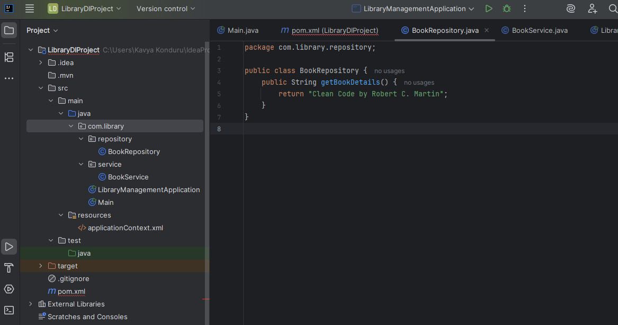

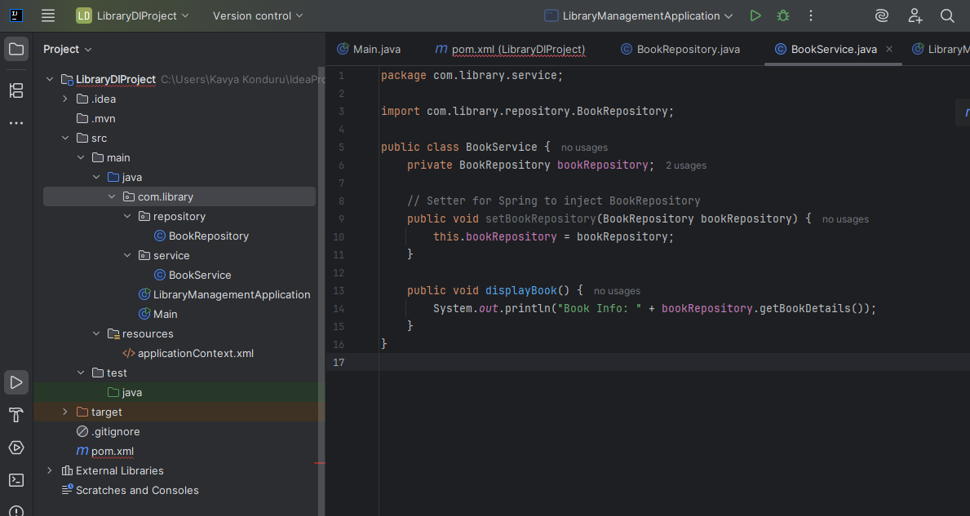

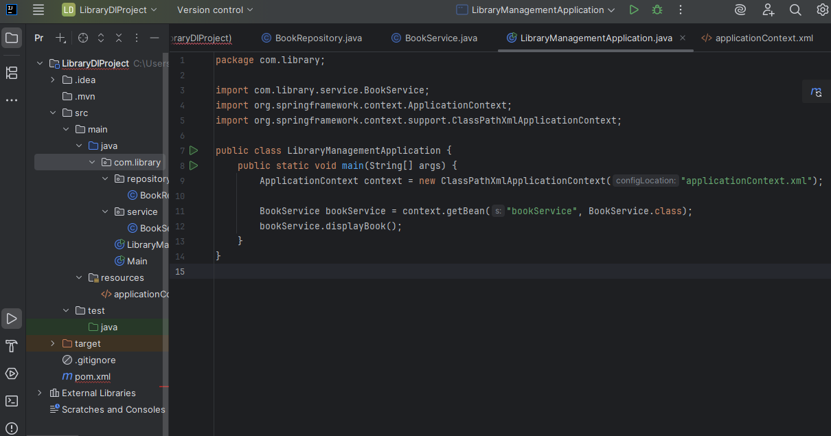

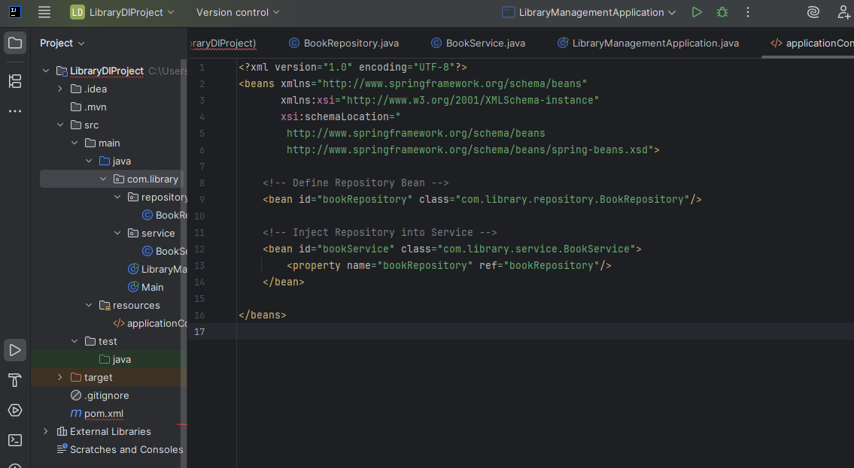

**OUTPUT:**

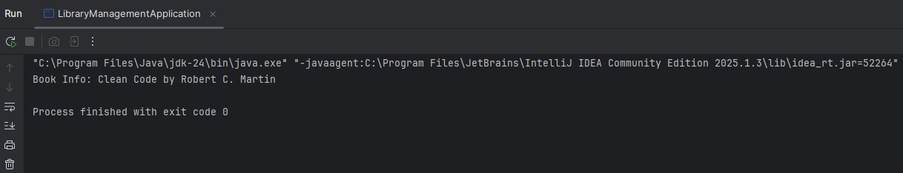

**Exercise 4: Creating and Configuring a Maven Project**

**Scenario:**

**You need to set up a new Maven project for the library management application and add Spring dependencies.**

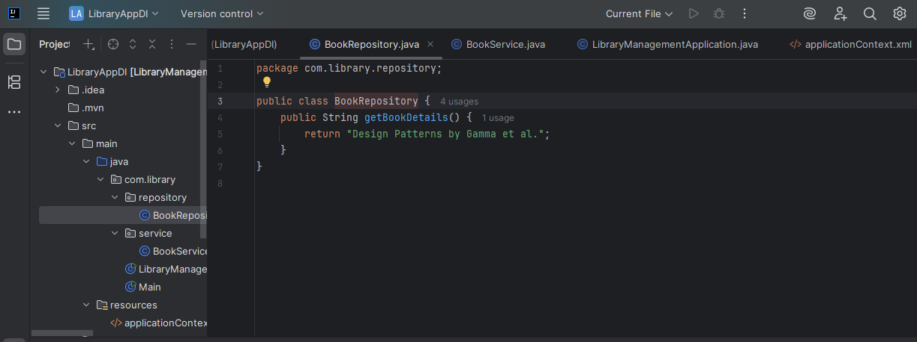

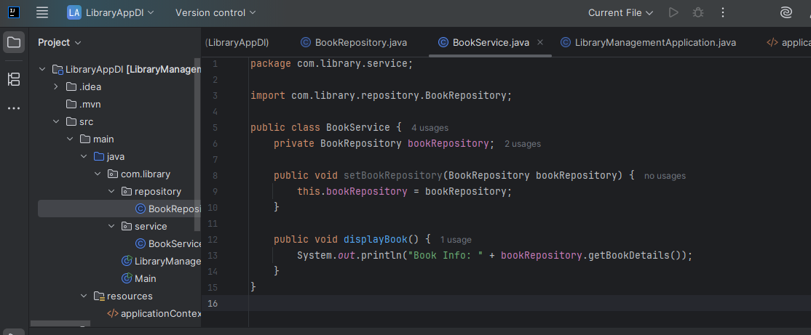

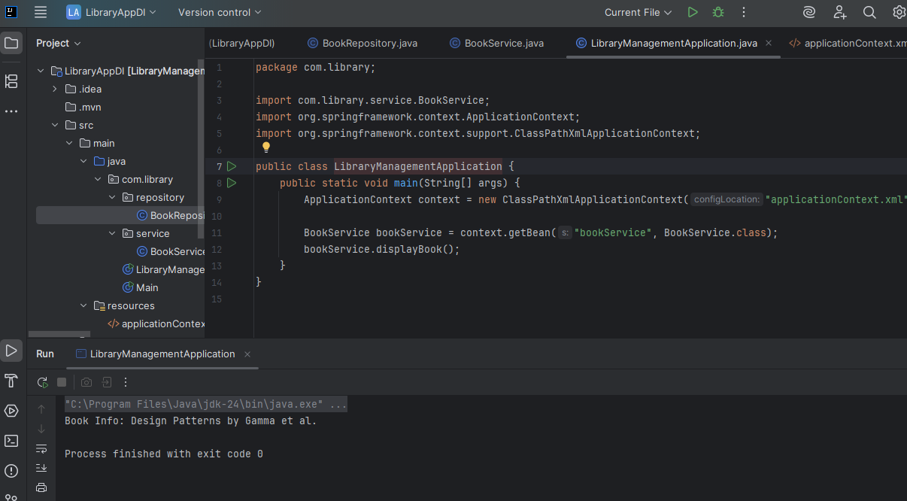

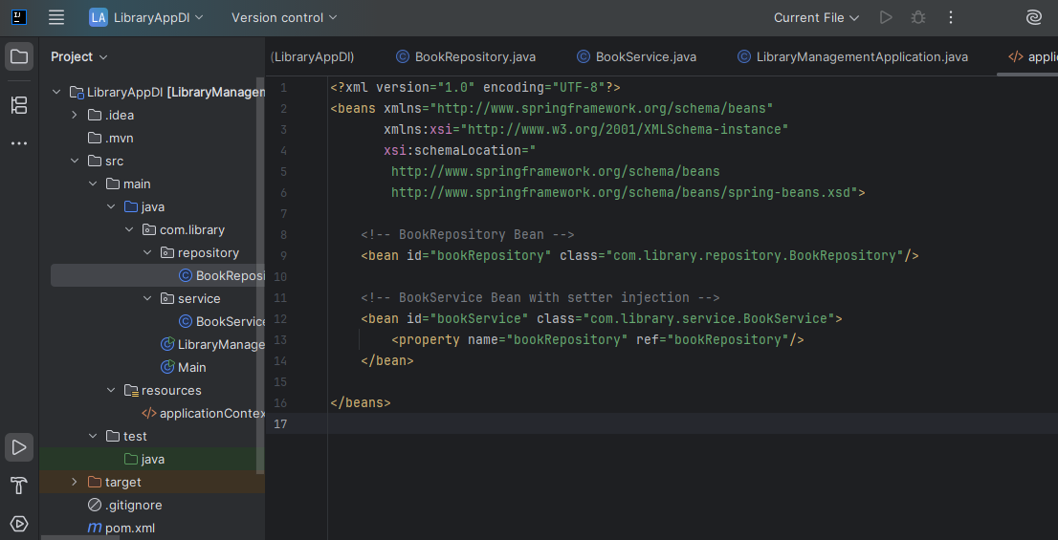

**OUTPUT:**

